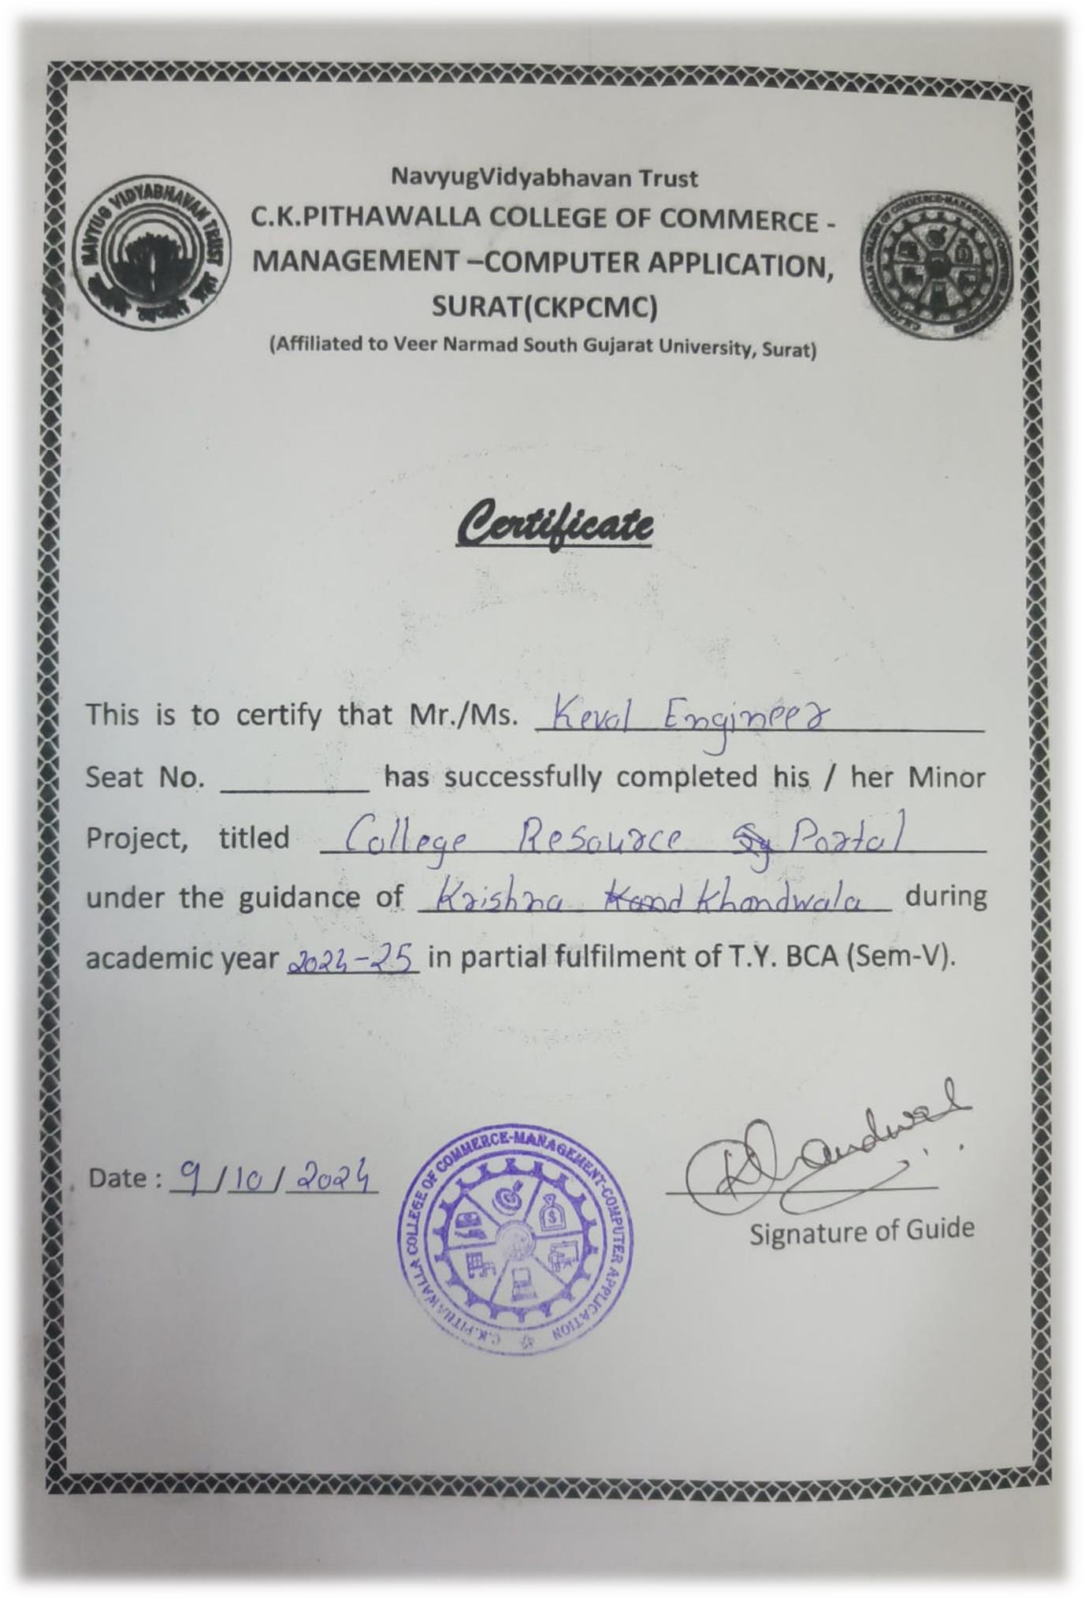

7577

Page **1of37**



##### C.K.Pithawalla College of Commerce-Management Computer Application, Surat

VEER NARMAD SOUTH GUJARAT UNIVERSITY, SURAT PROJECT REPORT

ON

**College Resource Potel**

BACHELOR OF COMPUTER APPLICATION

(B.C.A)

AY 2024-2025

## Project Title: College Resource Potel

By

|  |  |
| --- | --- |
| **Roll No** | **Student Name** |
| 124 | Keval Engineer R |

**Project Guide by:**

Pro.Krishna-Khandwala

Acknowledgement

The reason of completing the project work successfully is not just our efforts but efforts of many people. The people, who trusted, guided and encouraged us with every means. Guide is a person who provides you the direction towards success, so we feel great pleasure to express our gratitude to all our guides, our faculty members as well as every person who helped me directly or indirectly with our project.

We would like to thank **Dr. Marteen Patel Sir** (In-charge Principal at C.K.Pithawalla College) and **Mr. Gaurang Joshi Sir** (BCA-HOD at C.K.Pithawalla College) for granting us an opportunity to work on this project. Their skills and experience was a guiding path in this learning process. She made constant efforts to shape up our skills as per the industry Standards. She provided us a very homely and friendly environment which made it the best place to work. Their guidance was really priceless and will always be a guiding light in Industry.

We are also indebted to our Prof. **Krishna-Khandwala**

who provided constant encouragement, support & valuable guidance before and during our project. It was her effort who led us to this place for project work. Her guidance and suggestions were invaluable.

Thank you very much

Kahar Krishna c Engineer Keval r

INDEX

|  |  |  |
| --- | --- | --- |
| Sr.no | Description | Page No. |
| **1** | Introduction   * Project Profile * Project Summary | 5-6 |
| **2** | Environmental Specification   * Tech Setup (HW/SW) * Tech Resources (T&T) | 7-9 |
| **3** | System Analysis   * Exist System * Roles & Functions | 10-14 |
| 4 | Planned System   * Desire Benefits | 15 |
| **5** | Tables Overview | 16-22 |
| **6** | Detail Planning   * UML * Activity Diagram | 23-25 |
| **7** | System Design   * Admin Panel View * Teacher Panel View * Student Panel View | 26-37 |

# INTRODUCTION

## Project Profile

|  |  |
| --- | --- |
| Title | : “College Resource Portal” |
| Type | : College Management System |
| Objective | : “Build a one-stop shop for BCA-BBA-B-COM students, providing information on various topics such as course curriculum, faculty profiles alumni success stories, and downloadable study materials.” |
| Guide By | : Prof. Krishna-Khandwala |
| Team Member | : 2 |
| Front-End | : HTML, CSS, JavaScript |
| Back-End | : Unstructured Database “PHP |
| Frame Work | : PHP |
| Project Owner | :Engineer Keval R |

1. Project Summary

The " College Resource Portal " is a comprehensive College Management System designed to improve the organization and administration of college resources in college settings, with the primary goal.

Allow the Student and Teachers to manage Accounts effectively by performing CRUD operations (Create, Read, Update, Delete)

Admin manages the Student account like active Or inactive Account

Students can See and Download Subject Notes provided by the Admin.

Teacher can see The assign Subject-class notification given by admin.

# Environmental Specification

## Tech Setup (HW/SW)

**Hardware Requirement: -** A lot of requirements are

needed to prepare something. Furthermore, the process of making this particular website involves a lot of things that make it possible for me to reach it.

### For Large Device

##### Minimum Requirements: -

1> Processor: 6th Gen Intel® Core™ i3-6100 3.7 GHz 2> RAM: 4GB

3> Screen Resolution: 1366x768 4> Internet Connection

### For Medium Device

##### Minimum Requirements: -

1> Processor: ARM Cortex-A53, 1400 MHz, Cores:4 2> Memory: 2GB

3> Screen Resolution: 768x1024

4> Internet Connection

**Software Requirement: -** In addition to the hardware requirements, there are also a number of software requirements that contribute to the accessibility of the website.

### For Large Device

**Recommended Requirements: -** 1>Windows 7 or Higher 2>Browser

### For Medium Device

**Recommended Requirements: -** 1>Android 8 or Higher 2>Browser

## Tech Resources (T&T)

### Technology’s Used are: -

1. HTML
2. CSS
3. JavaScript
4. PHP DB

### Frame Work Used are: -

1. Bootstap Framework
2. Css

### Tools Used are: -

1. Visual Studio Code
2. MS Power Point
3. MS Word

# SYSTEM ANALYSIS

## Exist System

The existing system, known as College Resource Portal, is a Collage management platform developed using HTML , Bootstrap Frame Work , CSS and PHP DB. It consists of two main components: Admin panel and an student panel, each serving specific functions and features.

###### Admin Panel: -

The Admin Panel of College Resource Portal provides a comprehensive and efficient interface for College Admin, allowing them to manage the student and teachers Information with ease. Here's a detailed overview of what Admin can access and manage through the Student and Teacher panel.

1. **Home Introduction: -**

Administrators are greeted with an engaging introduction to collage details and teacher information’s, department details features for managing the college resource efficiently.

1. **Real-Time Inventory Tracking: -**

The system provides real-time tracking of Subjects Notes, allowing administrators to monitor book availability, checkouts.

1. **User-Friendly Interface: -**

The College panel is designed with a user-friendly interface, making it easy for administrators to navigate and manage Student Subject notes download efficiently.

###### Teacher Panel: -

* + Teacher Can login and manage its own profile
  + Teacher can see The Assign Subject-class notification given by admin.
  + Teacher can also change the password of its own account.

###### Student Panel: -

The student panel of College*-*Resource Portal offers A Student friendly and efficient interface, allowing

students to view their Department interactions seamlessly. Here's a detailed overview of what students can access and manage through the student panel:

1. **Personalized Dashboard: -**

The student panel offers a personalized dashboard where students can view Department, Subject Notes and download

1. **Easy Change password: -**

Students can easily Change their Account password

**4. User-Friendly Interface: -**

The student panel features a user-friendly interface, making it easy for students to browse the Subjects Notes Give By College admin.

## Roles & Function

#### Admin Roles

1. Login
2. Add, Update, Delete Students
3. Add, Update, Delete Teacher
4. Add, Delete Course
5. Add Course Details
6. Assign Subject to Teacher
7. Manage Teacher and Student Account Like Active and Deactivate

#### Teachers Roles

1. Login
2. Notification of assign subjects
3. Update its own profile
4. Manage Password

#### Student Roles

1. Login (With Provide Password and Permission by Admin)
2. View the College Syllabus
3. View Subject Notes
4. Download Subject Notes
5. Change Account password

# PLANNED SYSTEM

1. Desire Benefits
   * + Improve the books-notes distribution and student have to access any time used noted with-out any authentication.
     + Allows for freely and convenient download and finding of books with a user-friendly design.
     + Admin have access assign subject tools that assign the Course subject for the Teacher’s.
     + Resulting in time and effort savings.
     + Enhances the Collage system to provide a more structured and user-friendly experience for both students.

# TABLES OVERVIEW

### Login Table

The login table stores information about the College admin, students, teachers including their usernames and hashed passwords.

**Table name: -** Login

|  |  |  |  |  |  |
| --- | --- | --- | --- | --- | --- |
| Name | Type | collection | Null | Default | Extra |
| ID | int(11) |  | No | *None* | AUTO_INCREMENT |
| **user_id** | varchar(30) | *latin1_swedish_ci* | No | *None* |  |
| **Password** | varchar(30) | *latin1_swedish_ci* | No | *None* |  |
| **Role** | varchar(10) | *latin1_swedish_ci* | No | *None* |  |
| **Account** | varchar(20) | latin1_swedish_ci | No | *None* |  |

###### Add Student Table

**Use**:-The Add Student Table stores information about students.

**Table name: -** Student-Info

|  |  |  |  |  |  |
| --- | --- | --- | --- | --- | --- |
| Name | Type | collection | Null | Default | Extra |
| **roll_no** | int(20) |  | No | *None* | AUTO_INCREMENT |
| **first_name** | varchar(30) | *latin1_swedis h_ci* | No | *None* |  |
| **middle_na me** | varchar(30) | *latin1_swedis h_ci* | No | *None* |  |
| **last_name** | varchar(30) | *latin1_swedis h_ci* | No | *None* |  |
| **email** | varchar(30) | latin1_swedis h_ci | No | *None* |  |
| **mobile_no** | varchar | latin1_swedis h_ci | No | *None* |  |
| **course_co de** | varchar(11) | latin1_swedis h_ci | No | *None* |  |
| **Session** | varchar(10) | latin1_swedis h_ci | No | *None* |  |
| **profile_im age** | varchar(100) | latin1_swedis h_ci | No | *None* |  |
| **Dob** | varchar(10) | latin1_swedis h_ci | No | *None* |  |
| **Gender** | varchar(10) | latin1_swedis h_ci | No | *None* |  |
| **permanen t_address** | varchar(150) | latin1_swedis h_ci | No | *None* |  |
| **current_a ddress** | varchar(150) | latin1_swedis h_ci | No | *None* |  |
| **admission**  **_date** | Timestamp | latin1_swedis h_ci | No | current_timestamp() | ON UPDATE CURRENT_TIMESTAM P() |

###### Add Teacher Table

**Use**-The Add Teacher Table stores information about students.

**Table name: -** Teacher_Info

|  |  |  |  |  |  |
| --- | --- | --- | --- | --- | --- |
| Name | Type | collection | Null | Default | Extra |
| **teacher_id** | **int(11)** |  | No | ***None*** | AUTO_INCREMENT |
| **first_name** | **varchar(30)** | ***latin1_swedish_ci*** | **No** | ***None*** |  |
| **middle_name** | **varchar(30)** | ***latin1_swedish_ci*** | **No** | ***None*** |  |
| **last_name** | **varchar(30)** | ***latin1_swedish_ci*** | **No** | ***None*** |  |
| **email** | **varchar(30)** | **latin1_swedish_ci** | **No** | ***None*** |  |
| **phone_no** | **Varchar(11)** | **latin1_swedish_ci** | **No** | ***None*** |  |
| **profile_image** | **blob** |  | **No** | ***None*** |  |
| **teacher_status** | **varchar(20)** | **latin1_swedish_ci** | **No** | ***None*** |  |
| **Dob** | **varchar(15)** | **latin1_swedish_ci** | **No** | ***None*** |  |
| **Gender** | **varchar(10)** | **latin1_swedish_ci** | **No** | ***None*** |  |
| **permanent_address** | **varchar(150)** | **latin1_swedish_ci** | **No** | ***None*** |  |
| **current_address** | **varchar(150)** | **latin1_swedish_ci** | **No** | ***None*** |  |
| **hire_date** | **varchar(15)** | **latin1_swedish_ci** | **No** |  |  |

### Teacher _Courses Table

The Teacher _Courses Table maintains records of all books currently issued to students, including the unique identifiers for the student and the book, along with the issue date and due date.

**Table name: -** Teacher _Courses

|  |  |  |  |  |  |
| --- | --- | --- | --- | --- | --- |
| Name | Type | collection | Null | Default | Extra |
| **teacher_courses_id** | int(11) |  | No | *None* | AUTO_INCREMENT |
| **course_code** | varchar(10) | latin1_swedish_ci | No | *None* |  |
| **Semester** | int(11) |  | No | *None* |  |
| **teacher_id** | varchar(10) | latin1_swedish_ci | No | *None* |  |
| **subject_code** | varchar(10) | latin1_swedish_ci | No | *None* |  |
| **assign_date** | varchar(10) | latin1_swedish_ci | No | *None* |  |
| **total_classes** | int(11) |  | No | *NoneSS* |  |

**Table name: -** Courses

|  |  |  |  |  |  |
| --- | --- | --- | --- | --- | --- |
| Name | Type | collection | Null | Default | Extra |
| **course_code** | varchar(10) | latin1_swedish_ci | No | *None* |  |
| **course_name** | varchar(50) | latin1_swedish_ci | No | *None* |  |
| **semester_or_year** | varchar(10) | *latin1_swedish_ci* | No | *None* |  |
| **no_of_year** | int(10) |  | No | *None* |  |

**Table name: -** Courses_Subject

|  |  |  |  |  |  |
| --- | --- | --- | --- | --- | --- |
| Name | Type | Type | Null | Default | Extra |
| **subject_c ode** | varchar(10) | latin1_swedis h_ci | No | *None* |  |
| **subject_n ame** | varchar(50) | latin1_swedis h_ci | No | *None* |  |
| **course_co de** | varchar(10) | *latin1_swedis h_ci* | No | *None* |  |
| **semester** | int(10) |  | No | *None* |  |
| **credit_ho urs** | int(5) |  | No | *None* |  |

### 3.Subject_notes-Tables

The Subject notes bba,bca,b.com table maintains records of all books-notes which is uploaded by admin.

**Table name: -** B. B.A

|  |  |  |  |  |  |
| --- | --- | --- | --- | --- | --- |
| Name | Type | Type | Null | Default | Extra |
| **Sub_id** | int(11) |  | No | *None* | AUTO_INCREM ENT |
| **Sub_name** | varchar(50) | latin1_swedis  h_ci | No | *None* |  |
| **Sub_teacher** | varchar(50) | *latin1_swedis h_ci* | No | *None* |  |
| **Sub_file** | varchar(50) | latin1_swedis  h_ci | No | *None* |  |
| **sdetails** | varchar(50) | latin1_swedis  h_ci | No | *None* |  |
| **course** | varchar(50) | latin1_swedis  h_ci | No | *None* |  |
| **simg** | text | latin1_swedis  h_ci | No | *None* |  |

**Table name: -** B.C.A

|  |  |  |  |  |  |
| --- | --- | --- | --- | --- | --- |
| Name | Type | Type | Null | Default | Extra |
| **Sub_id** | int(11) |  | No | *None* | AUTO_INCREM ENT |
| **Sub_name** | varchar(50) | latin1_swedis  h_ci | No | *None* |  |
| **Sub_teacher** | varchar(50) | *latin1_swedis h_ci* | No | *None* |  |
| **Sub_file** | varchar(50) | latin1_swedis  h_ci | No | *None* |  |
| **sdetails** | varchar(50) | latin1_swedis  h_ci | No | *None* |  |
| **course** | varchar(50) | latin1_swedis  h_ci | No | *None* |  |
| **simg** | text | latin1_swedis  h_ci | No | *None* |  |

**Table name: -**B.com

|  |  |  |  |  |  |
| --- | --- | --- | --- | --- | --- |
| Name | Type | Type | Null | Default | Extra |
| **Sub_id** | int(11) |  | No | *None* | AUTO_INCREM ENT |
| **Sub_name** | varchar(50) | latin1_swedis  h_ci | No | *None* |  |
| **Sub_teacher** | varchar(50) | *latin1_swedis h_ci* | No | *None* |  |
| **Sub_file** | varchar(50) | latin1_swedis  h_ci | No | *None* |  |
| **sdetails** | varchar(50) | latin1_swedis  h_ci | No | *None* |  |
| **course** | varchar(50) | latin1_swedis  h_ci | No | *None* |  |
| **simg** | text | latin1_swedis  h_ci | No | *None* |  |

# DETAIL PLANNING

## UML

UML serves as a standardized language for articulating the operational framework of the College Management System. It comprises a collection of guidelines that software engineers utilize to create diagrams illustrating the system's design and its management of resources, including books, and circulation activities. These visual representations facilitate improved understanding and communication among all stakeholders in the system's development, such as Admin, analysts, designers, and developers, thereby ensuring that the system effectively addresses the requirements of the college community.

A Use Case diagram is like a comic strip that shows how users (called actors) will interact with the College Library Management System. There are a few main things in this diagram:

* **Actors**: These are the users who will be interacting with the system, such as Admin and students
* **Use Cases**: These represent the specific tasks or functions that the actors will perform when using the system, such as checking out download books, or information of the over collage.
* **System Boundary**: This is the box that represents the College Management System itself, and it contains all the use cases.

The Use Case diagram provides a high-level view of how the system will be used and what functionality it needs to provide to meet the needs of its users. It helps to identify the requirements of the system and ensures that everyone involved in developing the system has a clear understanding of its purpose and functionality.

UML: -

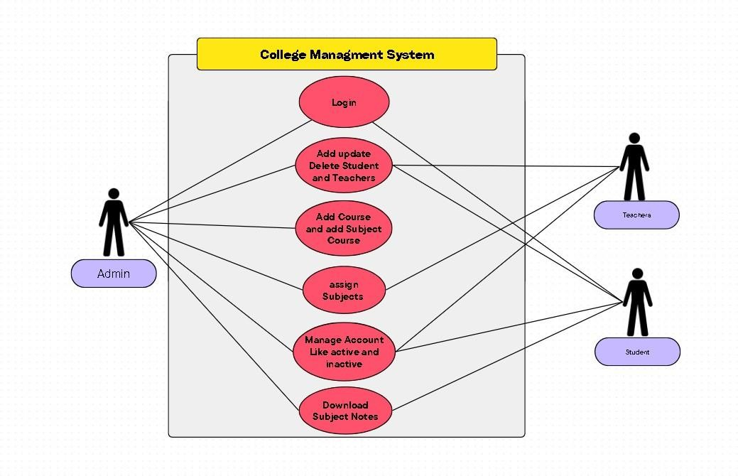

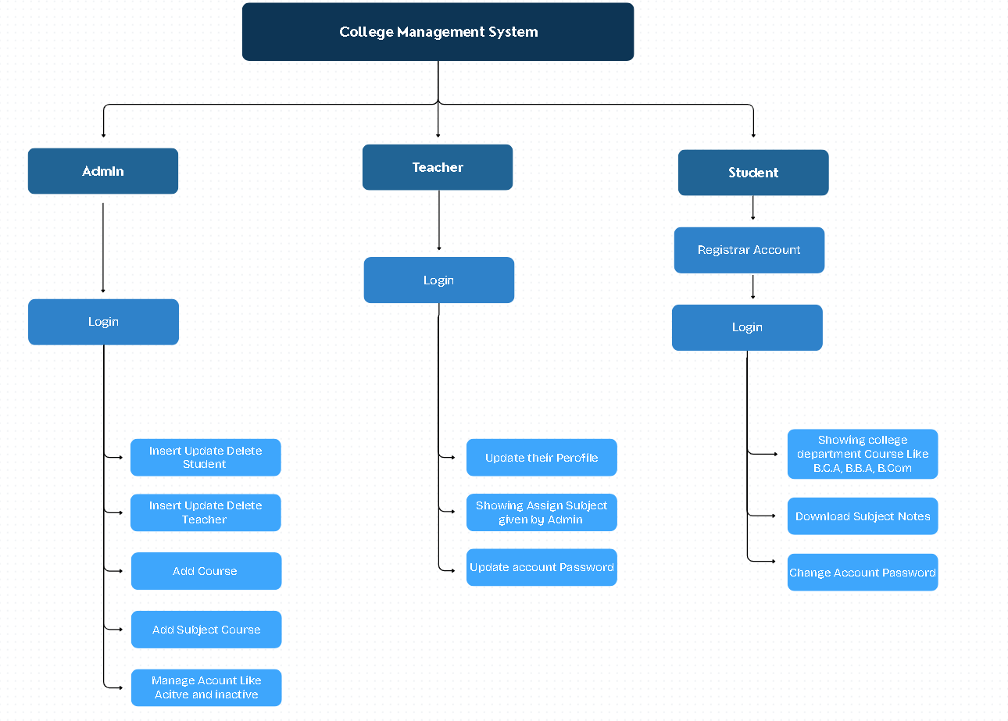

# ACTIVITY DIAGRAM

**SYSTEM DESIGN**

1. Admin Panel View

The College panel is a dynamic interface that adapts well to both large and medium devices; however, it is not visible on small devices.

**Adminlogin page**

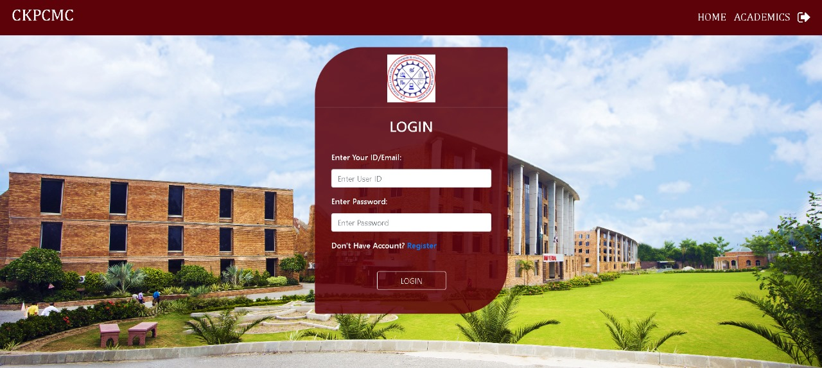

**AdminDashboard: -**

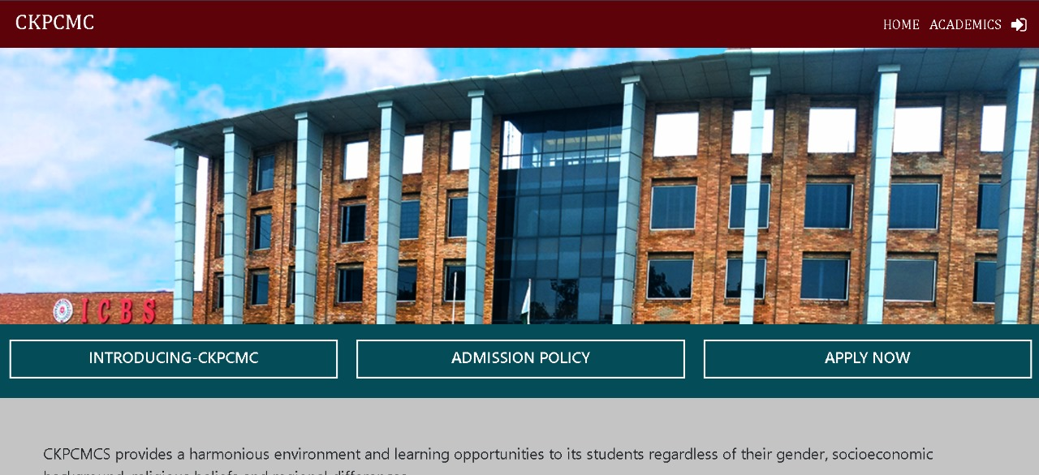

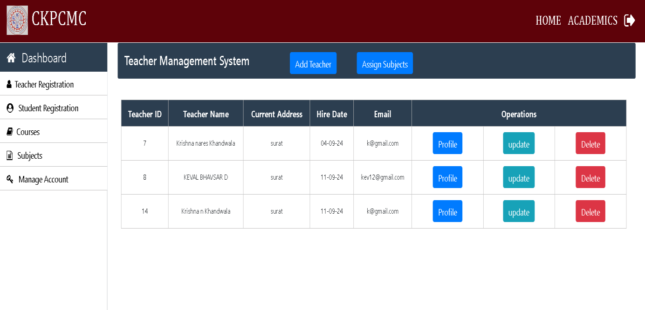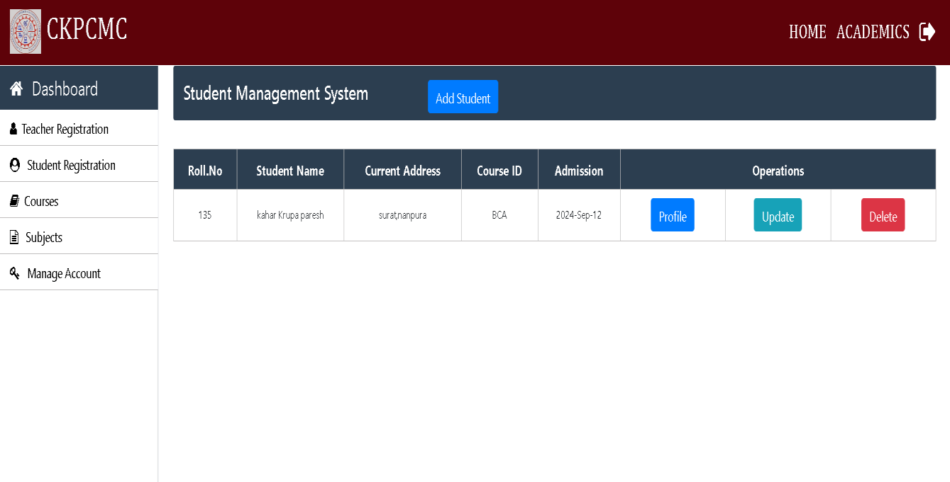

##### Admin teacher Registration

**Admin Student Registration**



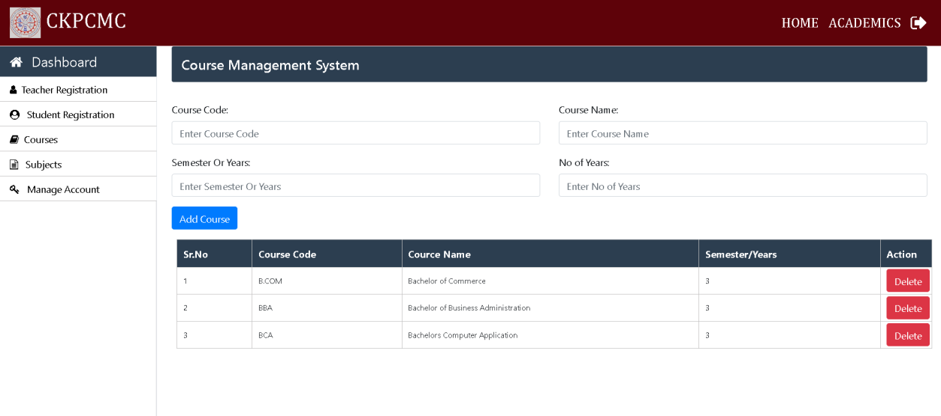

Admin can Add Course like B.B.A,B.C.A,B.Com

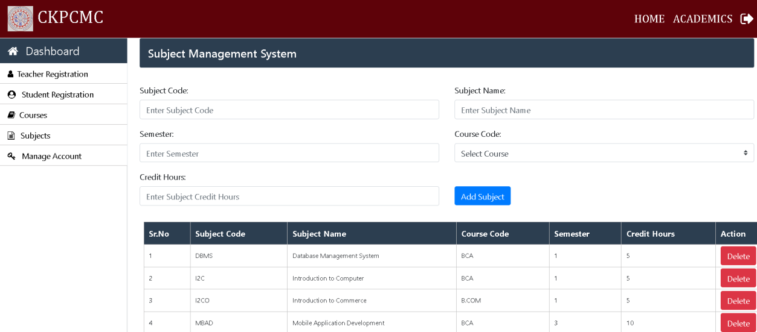

Admin can Add subject in Course Like CPPM, D.P.A, Economics etc.



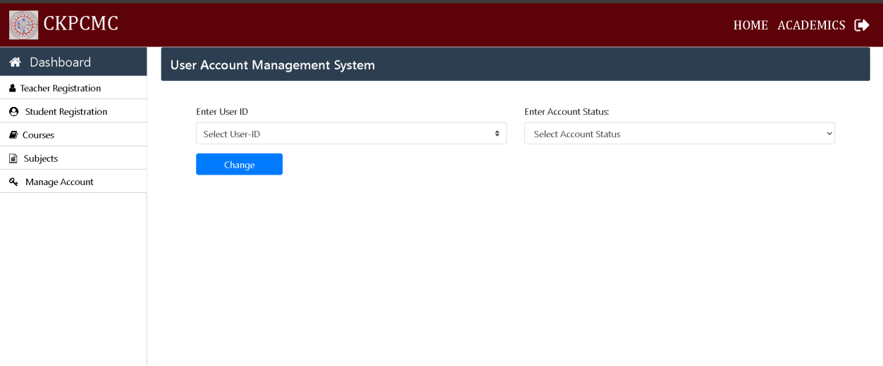

Here Admin can Manage Student And Teacher Account

Like Activate And Deactivate If admin Disactivate Student or Teacher Account Student or Teacher Can not Login.

Teacher Panel

##### Teacher Login Page:-

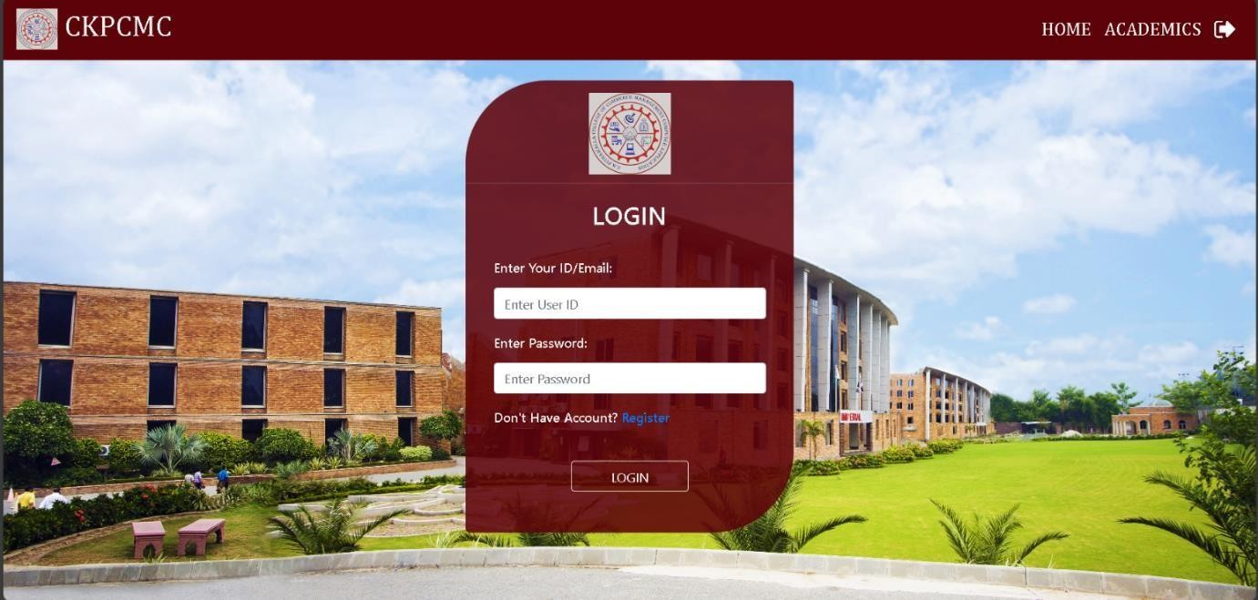

**Here Teacher Can Login their Profile**

**Teacher Dashboard: -**

**Here Teacher Can Show their Profile Update profile Show the assign Subject given by Admin And Also Change Password**

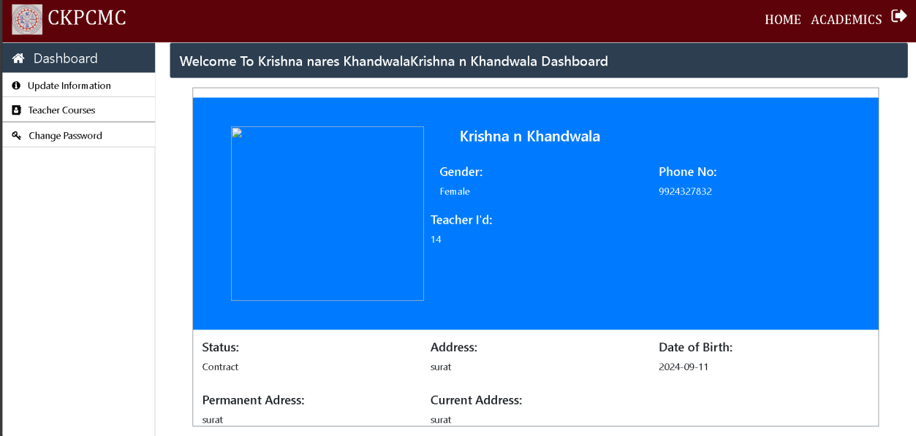

##### Student Panel

Dashboard:-



**Login:-**



**Registration Page:-**

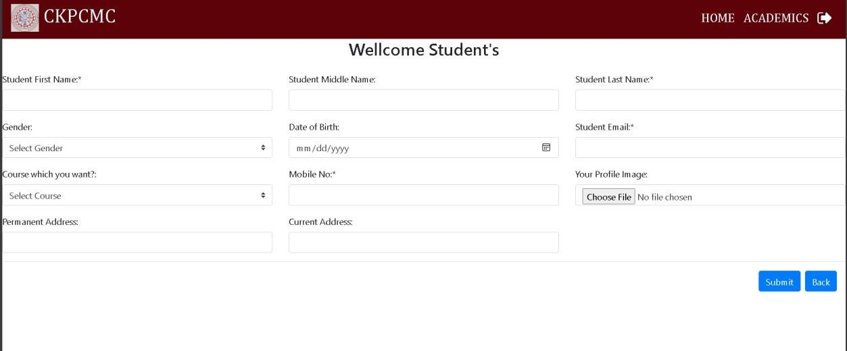

**Home:-**

**After Login student can See Home page**

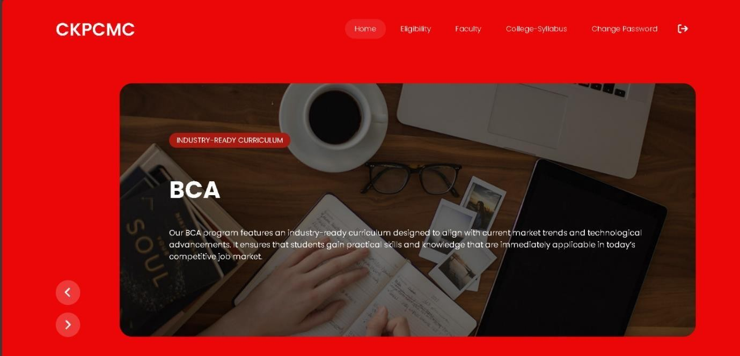

Home page of the website helps the user to navigate throughout the website.

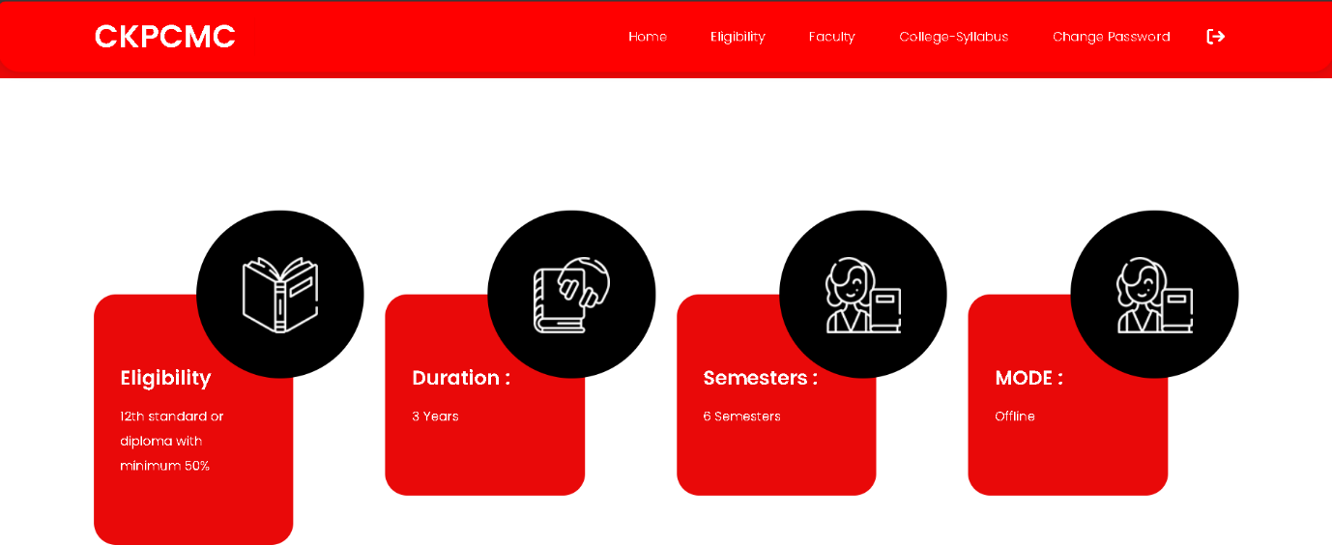

Here Student can Show the Eligibility Duration Course Semesters Course mode etc.

Here Student Can Show the Different Department Facultys.

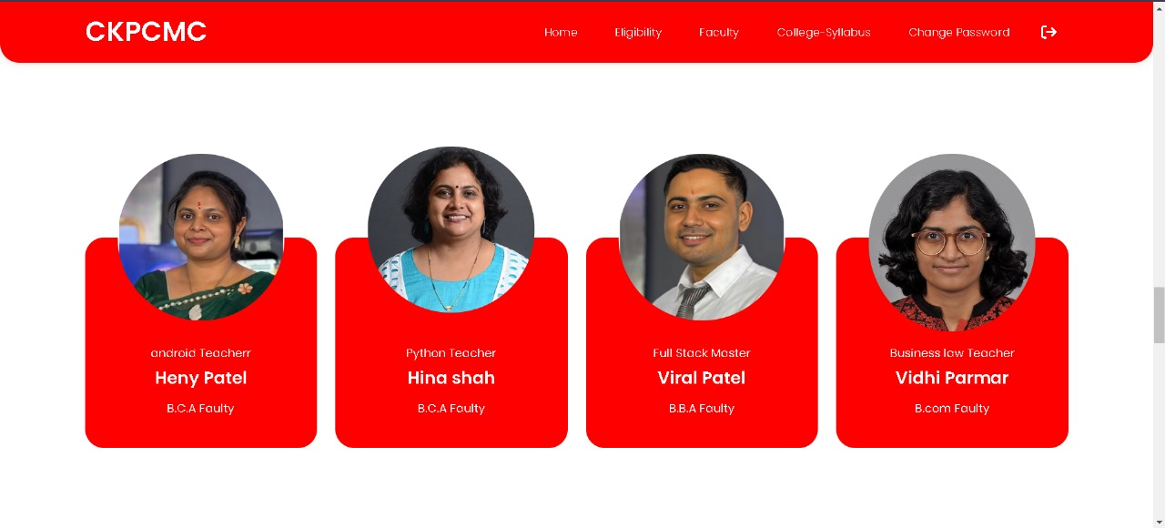

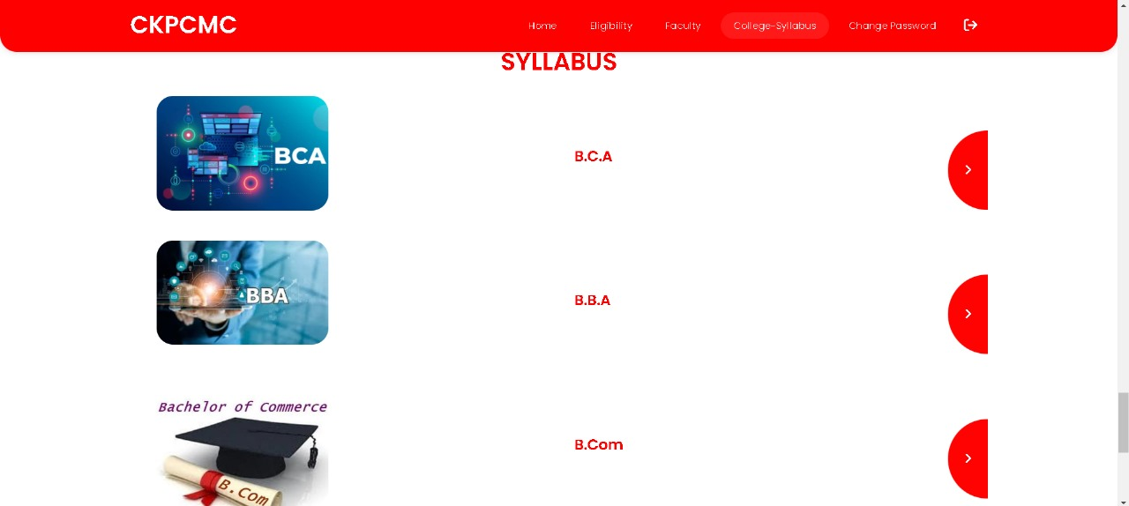

Student Show there Course Like BCA,BBA,Bcom For Download Subject notes

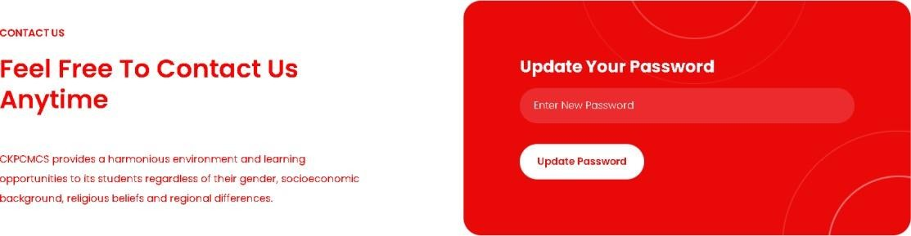

Here Student Can Change Password Their Profile.

##### BCA Subject Notes Page:-

Here Student Can Only see B.C.A Subjects Notes and Show the Details Like Semesters subject name teacher name who upload file and download icon to download subject Pdf

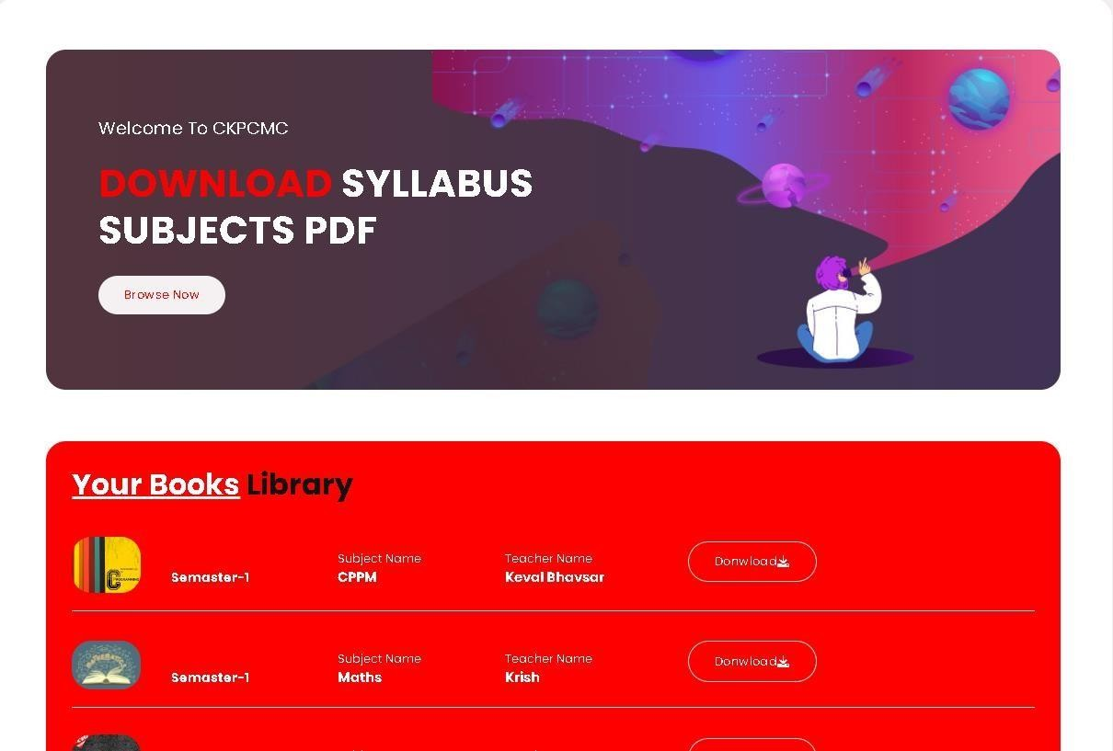



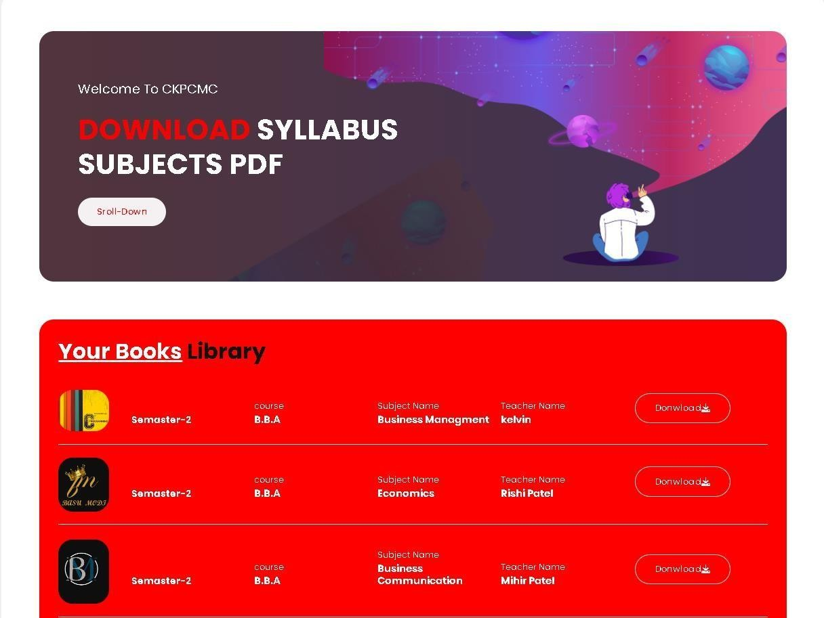

Here Student Can Only see B.B.A Subjects Notes and Show the Details Like Semesters, Subject name, teacher name who upload file and download icon to download subject Pdf



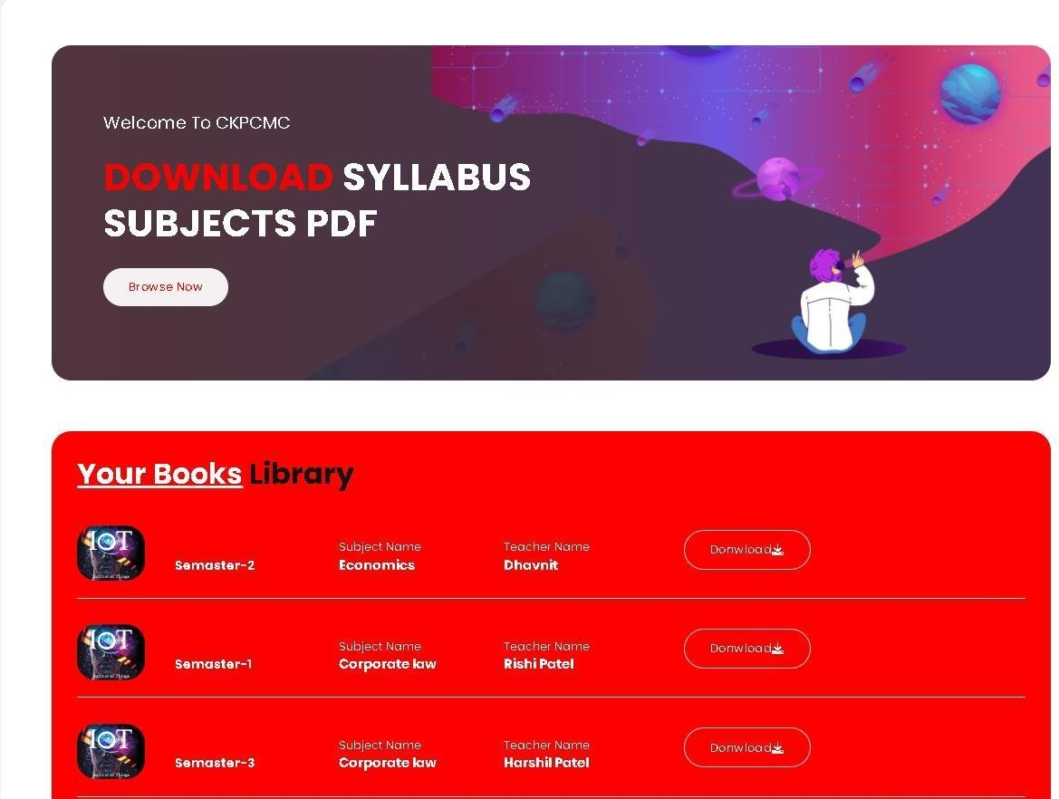

Here Student Can Only see B.com Subjects Notes and Show the Details Like Semesters, Subject name, teacher name who upload file and download icon to download subject Pdf.